Practical no. 14
Name :- Danish Altaf Solkar Enrolment no. :-24111590805
Class :- CO3K – B Subject :- DMS
Aim:- Implement queries using Aggregate functions

QUERY :- select * from emp2 order by eno;
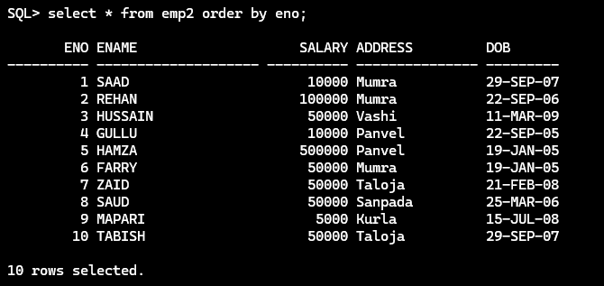

QUERY :- select sum (salary) from emp2;
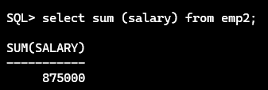

QUERY :- select avg (salary) from emp2;
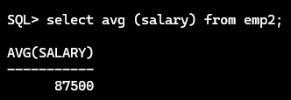

QUERY :- select max (salary) from emp2;
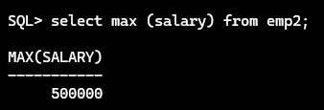

QUERY :- select min (salary) from emp2;
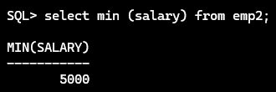

QUERY :- select count (address) from emp2;
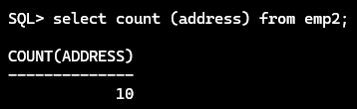

QUERY :- select count (distinct address) from emp2;
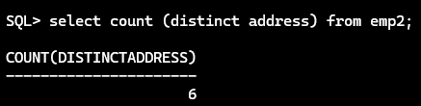

QUERY :- select count (*) from emp2;
